Lab 7.1.6 - Use Wireshark to Examine Ethernet Frames Topology – Windows version
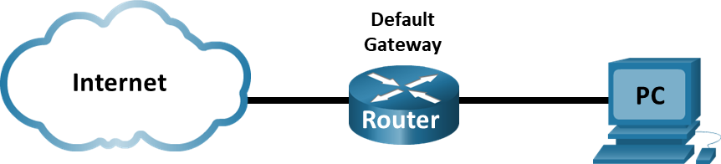

Objectives
Part 1: Use Wireshark to Capture and Analyze ICMP Ethernet Frames
Part 2: Use Wireshark to Capture and Analyze ARP Ethernet Frames

Background / Scenario
When upper layer protocols communicate with each other, data flows down the Open Systems Interconnection (OSI) layers and is encapsulated into a Layer 2 frame. The frame composition is dependent on the media access type. For example, if the upper layer protocols are TCP and IP and the media access is Ethernet, then the Layer 2 frame encapsulation will be Ethernet II. This is typical for a LAN environment.
When learning about Layer 2 concepts, it is helpful to analyze frame header information. In the first part of this lab, you will review the fields contained in an Ethernet II frame. In Part 2, you will use Wireshark to capture and analyze Ethernet II frame header fields for local and remote traffic.

Required Resources
- 1 Windows PC with internet access and with Wireshark installed, see previous Lab 3.7.1 for instructions on installing Wireshark.

Instructions
- Enter your screenshots/answers below the items highlighted in blue and turn in the completed file without making any changes to the original content.
- This Lab cannot be completed using NetLab. Complete using a computer with Internet Access.
- Once the Lab is graded it cannot be resubmitted for a new grade.

Part 1: Use Wireshark to Capture and Analyze ICMP Ethernet Frames

Review the Ethernet II header field descriptions and lengths.

Preamble | Destination  Address | Source  Address | Frame  Type | Data | FCS
8 Bytes | 6 Bytes | 6 Bytes | 2 Bytes | 46 – 1500 Bytes | 4 Bytes

Examine the network configuration of the PC.
For this lab, you will need to retrieve your computer IP address and its network interface card (NIC) physical address, also called the MAC address.
      - From a command prompt enter the ipconfig /all command and provide a screenshot of the output. (10 points)

Set the filter in Wireshark to display only ICMP traffic.
You can use the filter in Wireshark to block visibility of unwanted traffic. The filter does not block the capture of unwanted data; it only filters what you want to display on the screen. For now, only ICMP traffic is to be displayed.
Start Wireshark and in the Filter box, type icmp. The box should turn green if you typed the filter correctly. If the box is green, click Apply (the right arrow) to apply the filter.

Open a command prompt on your PC and ping the default gateway. Use the screenshot you took in Step 2 above to find the address of the default gateway.

Stop capturing traffic on the NIC.
Click the Stop Capturing Packets icon to stop capturing traffic.

Provide a screenshot of Wireshark showing the captured ICMP frames. (10 points)

Examine the first Echo (ping) request in Wireshark.
The Wireshark main window is divided into three sections: the packet list pane (top), the Packet Details pane (middle), and the Packet Bytes pane (bottom or side). If you selected the correct interface for packet capturing previously, Wireshark should display the ICMP information in the packet list pane of Wireshark.
      - In the packet list pane (top section), click the first frame listed. You should see Echo (ping) request under the Info heading. The line should now be highlighted.
      - Examine the first line in the packet details pane (middle section). This line displays the length of the frame.
      - The second line in the packet details pane shows that it is an Ethernet II frame. The source and destination MAC addresses are also displayed.
What is the MAC address of your computer’s NIC? (3 points)

What is the default gateway’s MAC address? (3 points)
      - You can click the greater than (>) sign at the beginning of the second line to obtain more information about the Ethernet II frame.
What type of frame is displayed? (3 points)

      - The last two lines displayed in the middle section provide information about the data field of the frame. Notice that the data contains the source and destination IPv4 address information.
What is the source IP address? (3 points)

What is the destination IP address? (3 points)

      - You can click any line in the middle section to highlight that part of the frame (hex and ASCII) in the Packet Bytes pane (bottom or side section). Click the Internet Control Message Protocol line in the middle section and examine what is highlighted in the Packet Bytes pane
What do the last two highlighted octets spell?(3 points)

      - Click the next frame in the top section and examine an Echo reply frame. Notice that the source and destination MAC addresses have reversed, because this frame was sent from the default gateway router as a reply to the first ping.
What device and MAC address is displayed as the destination address? (5 points)

Capture packets for a remote host.
      - Click the Start Capture icon to start a new Wireshark capture. You will receive a popup window asking if you would like to save the previous captured packets to a file before starting a new capture. Click Continue without Saving.
      - From a command prompt window, ping www.cisco.com.
Note: Windows may use IPv6 addresses when pinging remote hosts. To force Windows to use IPv4 addressing instead of IPv6 addressing, use the following syntax: ping -4 www.cisco.com

      - Stop capturing packets.
      - Examine the new data in the packet list pane of Wireshark.

In the first echo (ping) request frame, what are the source and destination MAC addresses?

Source (3 points):

Destination (3 points):
What are the source and destination IP addresses contained in the data field of the frame?

Source (3 points):

Destination (3 points):

Compare these addresses to the addresses you received in Step 6. The only address that changed is the destination IP address. Why has the destination IP address changed, while the destination MAC address remained the same? (10 points)

Part 2: Examine Ethernet frames with ARP payload in a Wireshark capture.
ARP stands for address resolution protocol. ARP is a communication protocol that is used for determining the MAC address that is associated with the IP address.
A computer saves the IP addresses and their associated MAC addresses learned using ARP in an ARP cache, so it doesn’t have to broadcast to obtain the MAC addresses for every transaction.
You can see the ARP cache using the command arp – a from the command prompt window.
You can delete entries in the arp cache by using the command arp -d from the command prompt. To delete all arp entries from the cache use arp -d *

Note: You must be in the administrator mode to delete the arp cache. Right click on the CMD and run it as Administrator.

Step 1: Start Wireshark and set enter arp in the Wireshark filter to view only frames with ARP payload.

Step 2: Delete all entries from the arp cache.

Step 3: Ping the default gateway which will generate an arp request from your PC to obtain the MAC address of the default gateway.

Step 4: Locate an arp broadcast frame like the one shown in the screenshot below:
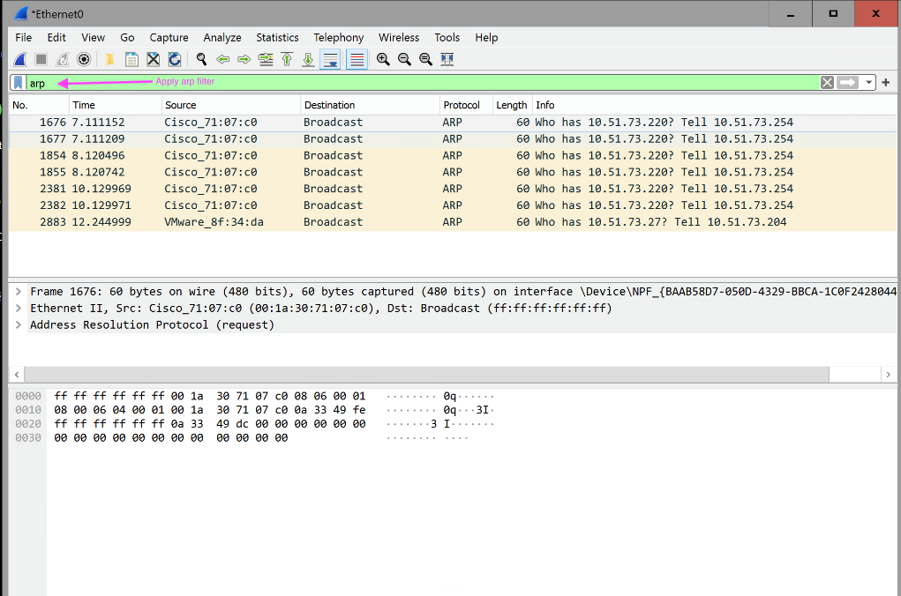

Provide a screenshot like the one above. (10 points)

Step 5: Examine the Ethernet II header contents of an ARP broadcast request.

a. Analyze one of the broadcast frames you captured to answer the following questions:

What is the destination MAC address? (5 points)

What is the source MAC address of the sender? (5 points)

What is the Vendor ID (OUI - Organization Unique Identifier)? (5 points)

What is the NIC serial number of the sender MAC address? (5 points)

What is the type of the Ethernet frame? (5 points)

